PyTorch官网Examples
Examples: easy to understand pytorch code across all domains
https://github.com/pytorch/examples
环境：
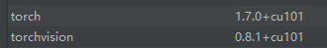

01 regression/main
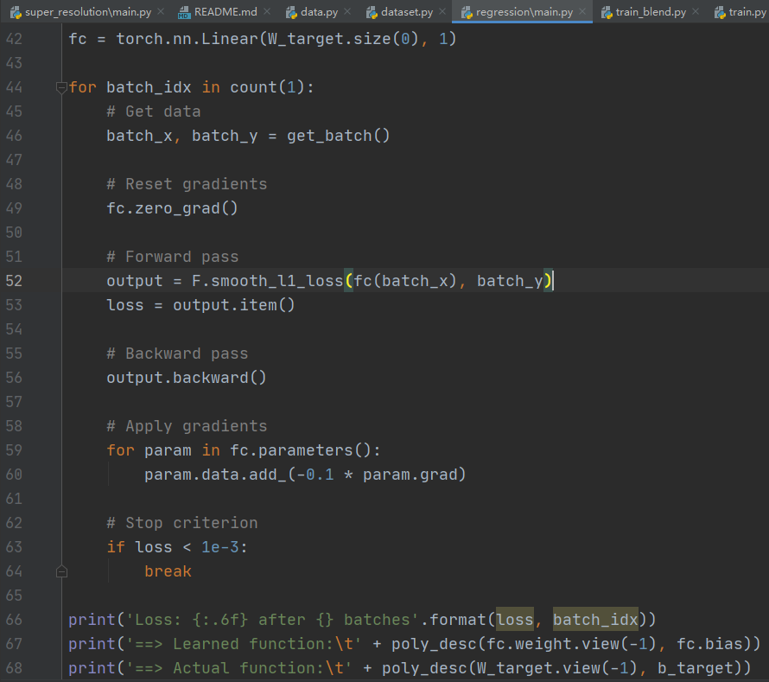
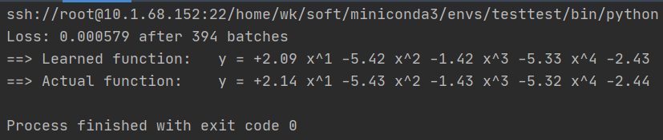
OK

02 mnist/main.py
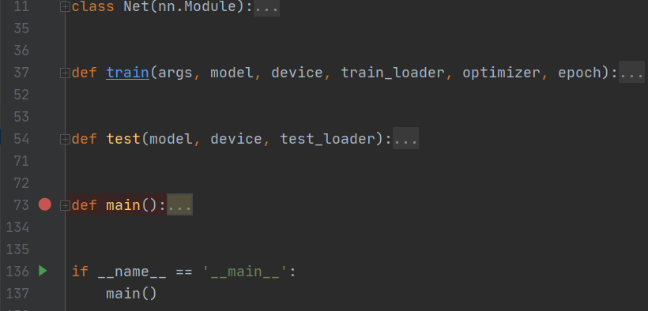
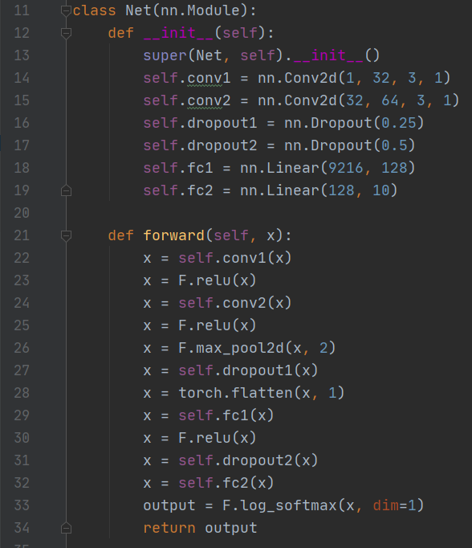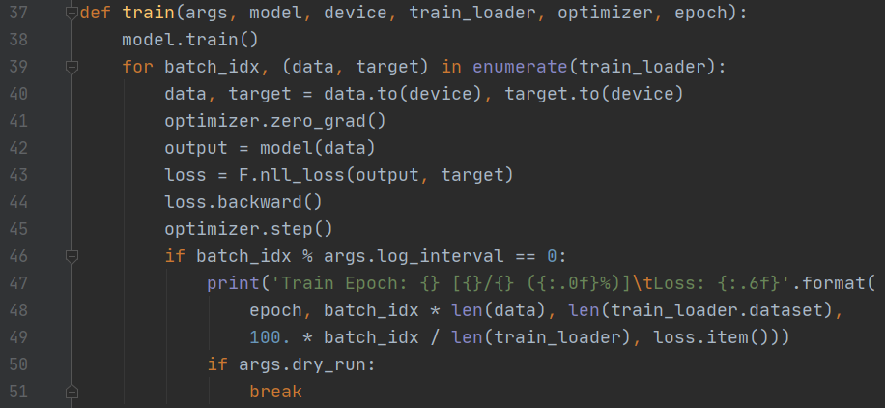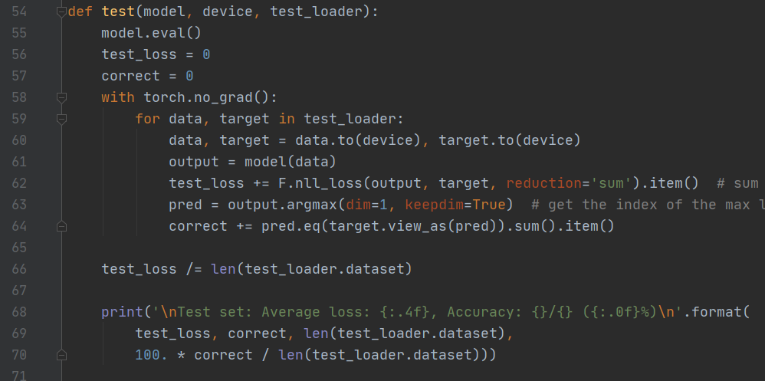
数据集mnist下载好后拷贝到指定路径../data
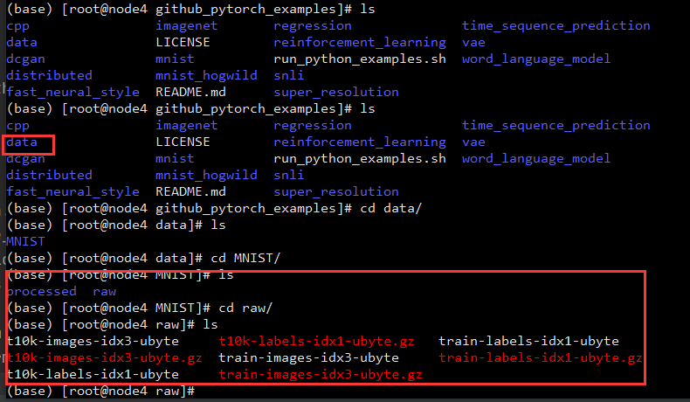
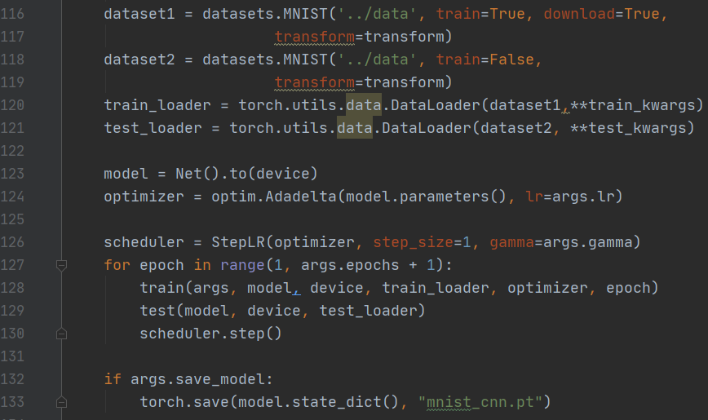
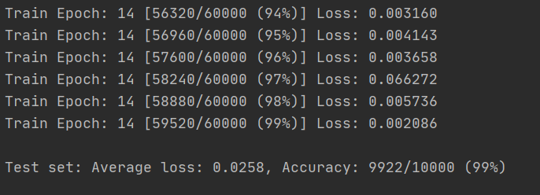
OK

03 mnist_hogwild/main.py
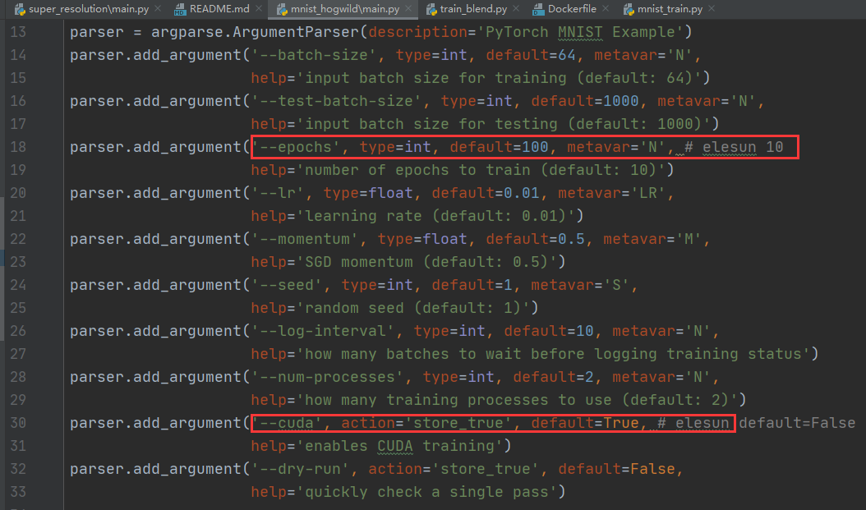
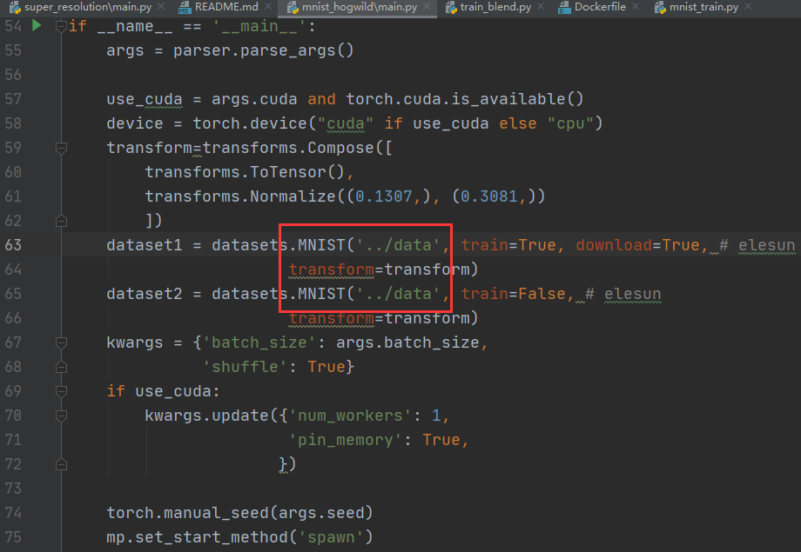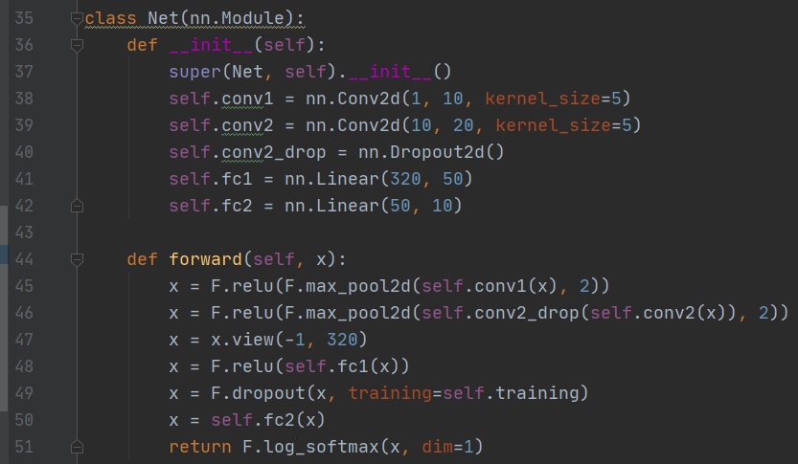
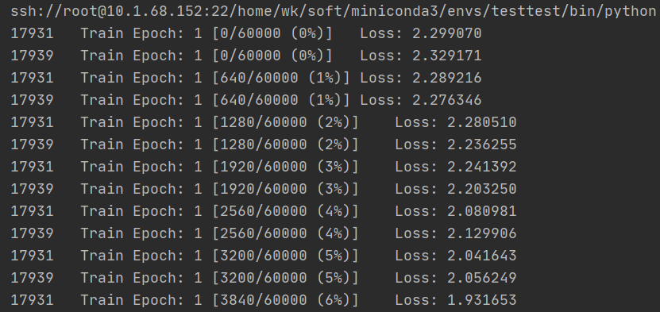
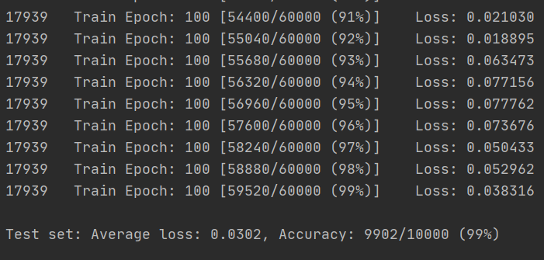

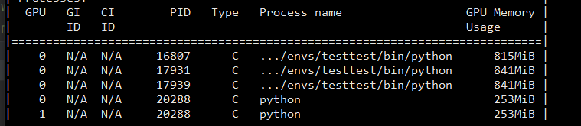
OK

04 time_sequence_prediction/train.py
先运行generate_sine_wave.py生成文件traindata.pt
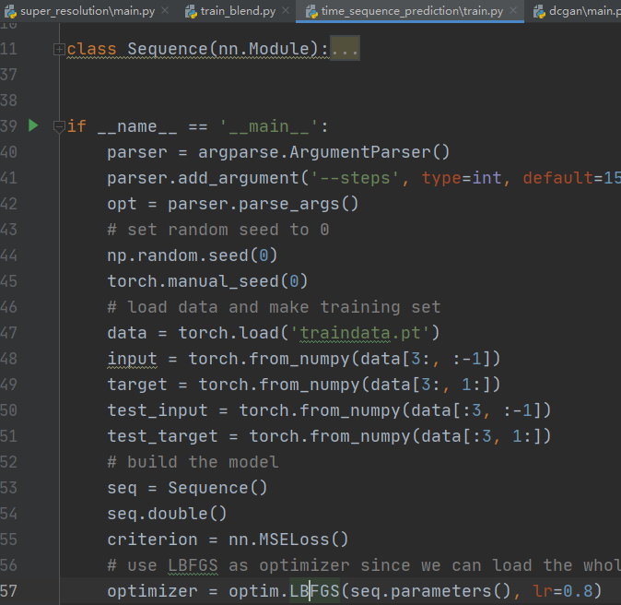
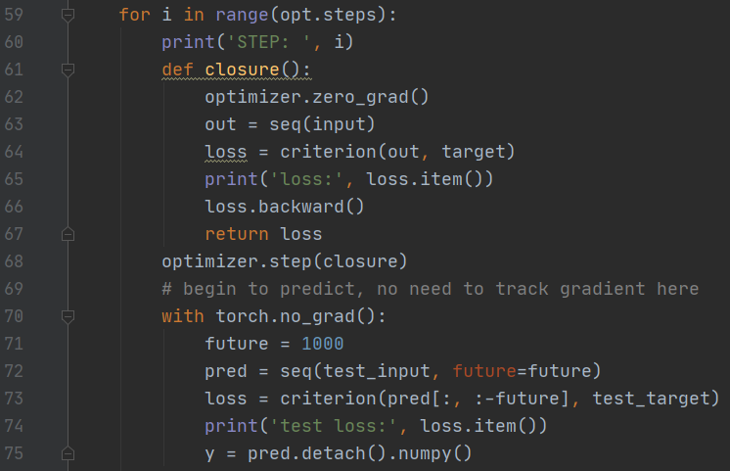
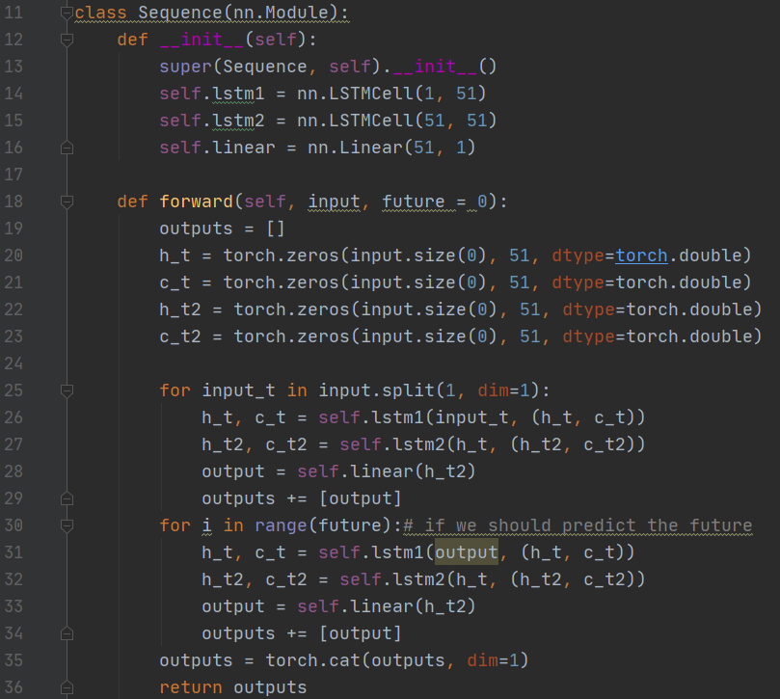
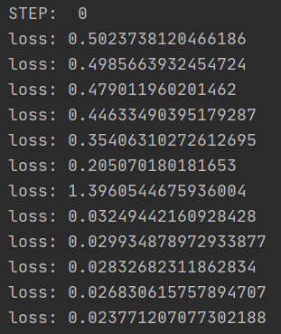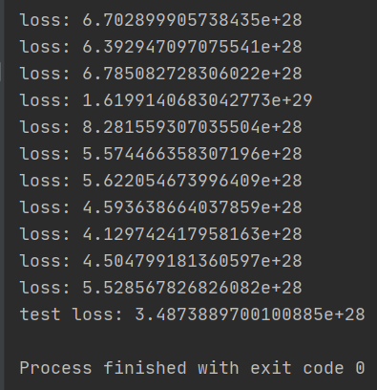
OK

05 dcgan/main
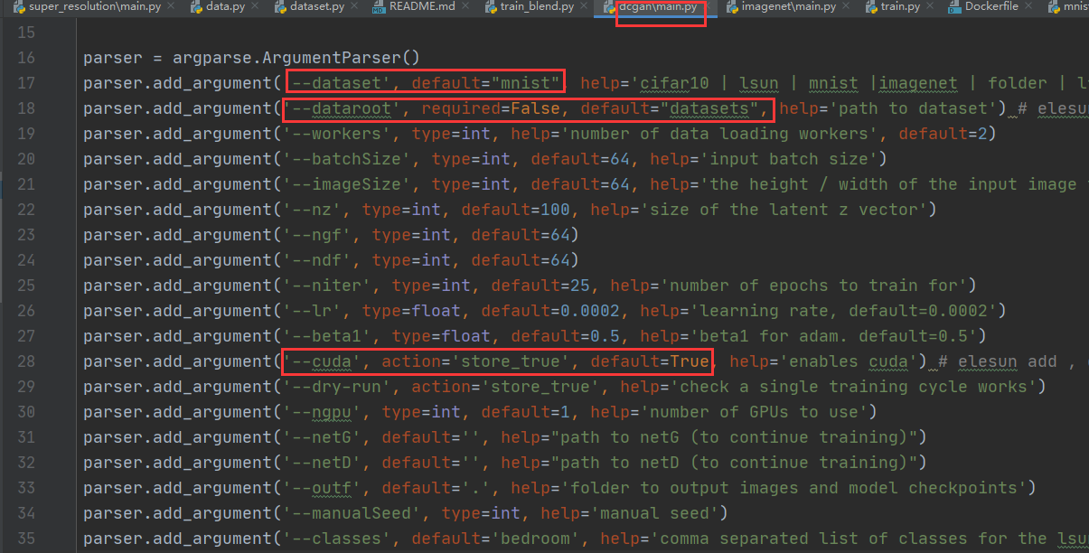
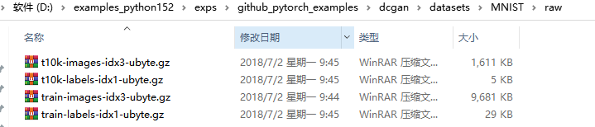
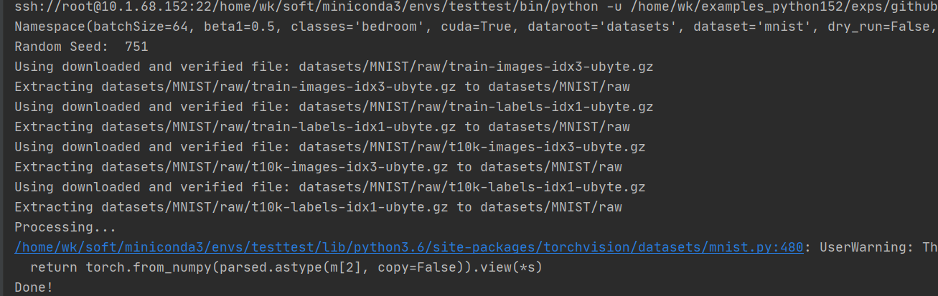
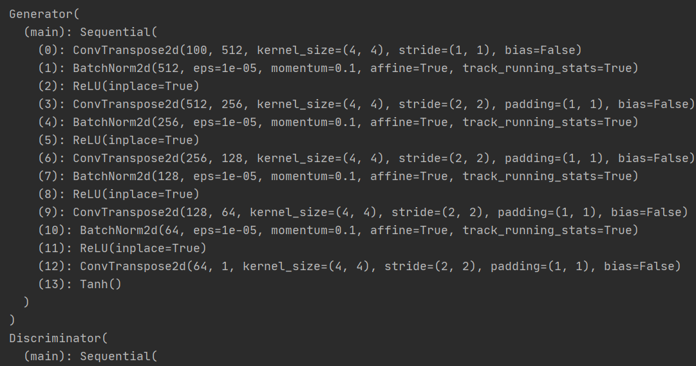
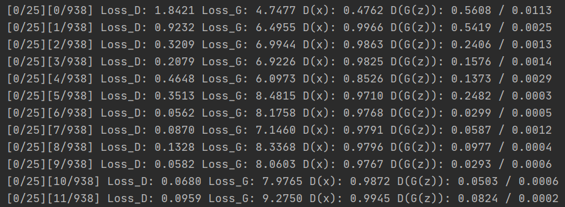
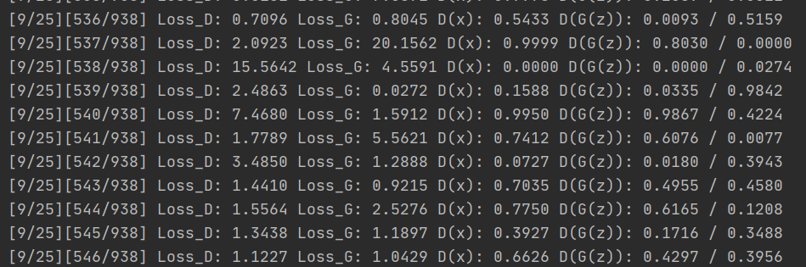
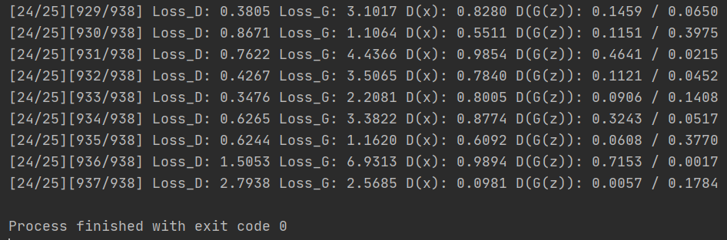
OK

06 super_resolution/main
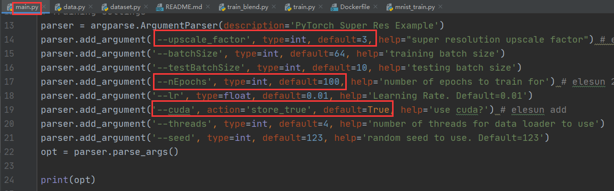
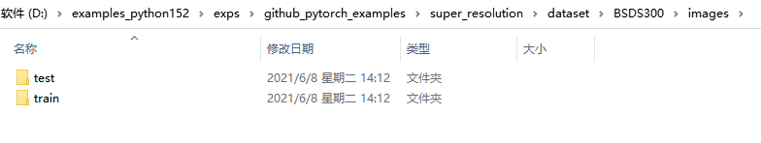
http://www2.eecs.berkeley.edu/Research/Projects/CS/vision/bsds/BSDS300-images.tgz

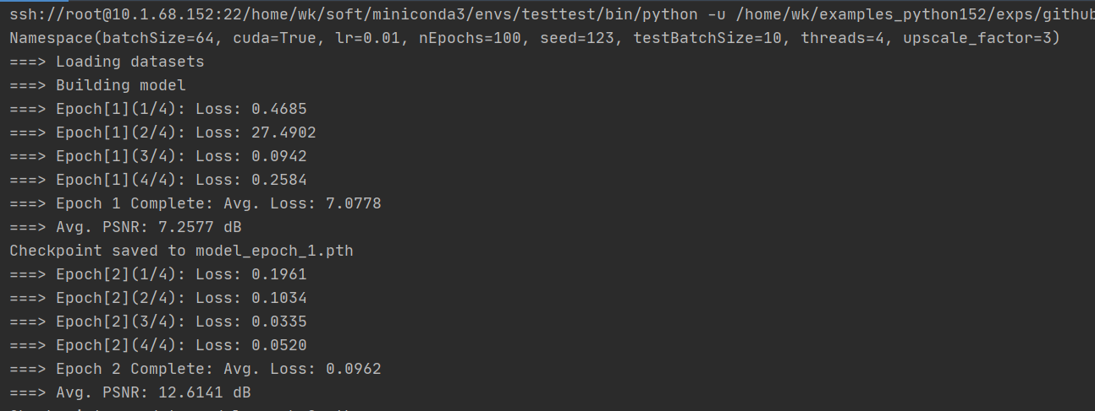
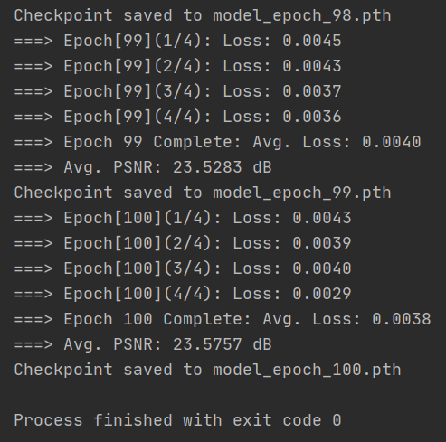
OK

07 word_language_model/main
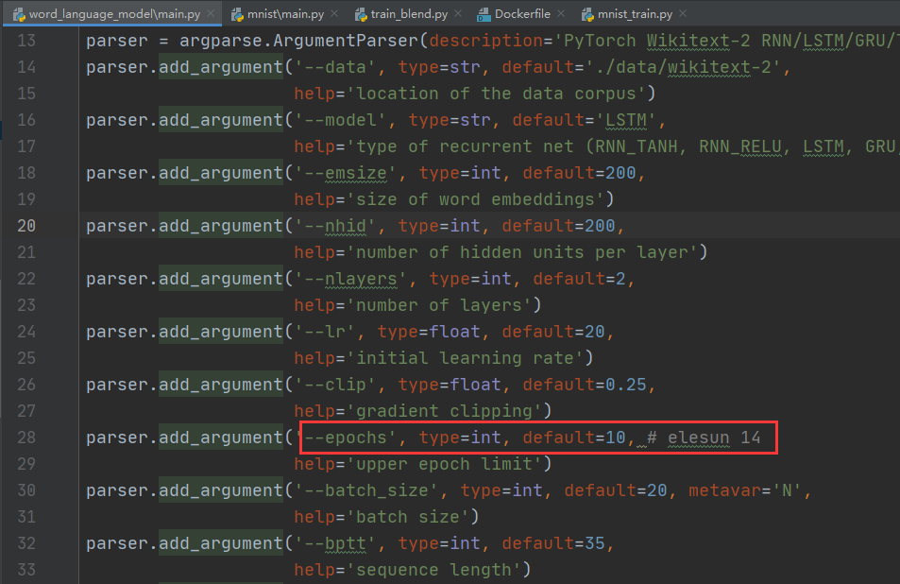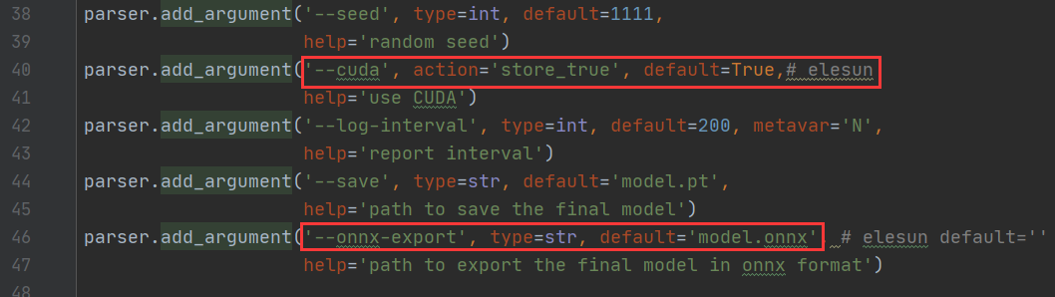
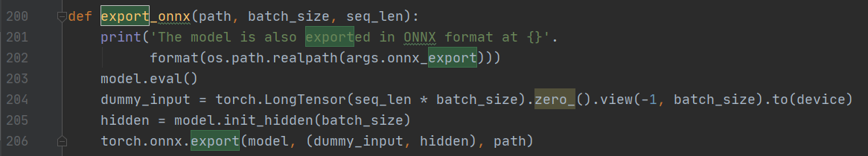
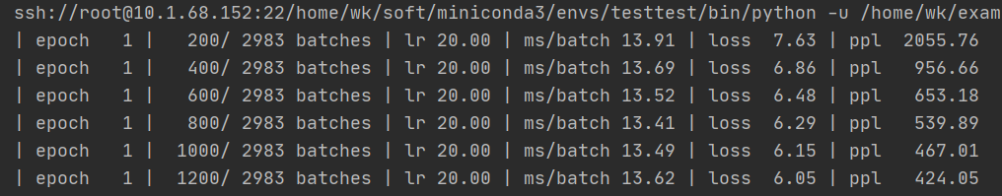
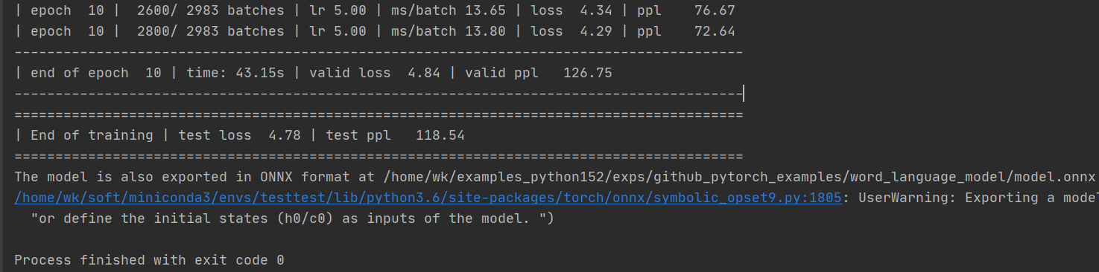
OK

问题：
Pytorch数据集下载MNIST数据缓慢的方案
https://blog.csdn.net/dogknow/article/details/108695653 实验成功
http://yann.lecun.com/exdb/mnist/ 数据下载
https://blog.csdn.net/xdl229/article/details/107718745
https://www.cnblogs.com/recoverableTi/p/12250622.html
手动下载mnist数据集，拷贝到datasets.MNIST('../data'）下raw目录（需要先运行main生成data/MNIST/raw文件夹），不用更改mnist.py resources OK
